**Analytics for Hospitals Health-Care Data**

**ABSTRACT:**

Analytics for hospital health care data provids a deep analysis on the research field of healthcare data analytics and it improves healthcare performance in many areas such as medical operations, reports, decision making, prediction and prevention system. Healthcare analytics refers to the use of vast amounts of collected data to provide organizations with actionable insights. These insights are developed through analytical disciplines to drive fact-based decision making using IBM cognos analytics and building visualizations of healthCare to create meaningful dashboards.In turn, these decisions improve planning, management, measurement and learning.The final dashboard helps healthcare organizations around the world to reduce costs, improves coordination.

**INTRODUCTION:**

Today’s healthcare industries are moving from volume-based business into value-based business, which requires an overwork from doctors and nurses to be more productive and efficient. This will improve healthcare practice, changing individual life style and driving them into longer life, prevent diseases, illnesses and infections. Over the last few years, healthcare data has become more complex for the reason that large amount of data are being available lately, along with the rapid change of technologies and mobile applications and new diseases have discovered. Therefore, healthcare sectors have believed that healthcare data analytics tools are really important subject in order to manage a large amount of complex data, which can lead to improve healthcare industries and help medical practice to reach a high level of efficiency and work flow accuracy.

**EXISTING SYSTEM:**

In the [healthcare](https://www.boldbi.com/blog/healthcare-metrics-and-kpis-to-track-and-improve-your-services) field, there is a need to monitor a wide variety of KPIs. For example, you may need to track hospital wait times and readmission rates. Similarly, you might need to analyze a clinic’s diagnostic trends. This data can certainly help ensure the health and satisfaction of patients and staff alike. Further, it impacts the longterm financial security of any medical office. Whether you need to analyze physician’s workloads or track patient satisfaction, Bold BI’s fully customizable dashboards put the healthcare KPIs you depend on at your fingertips, making it easy to increase your team’s transparency and efficiency.

This below hospital management dashboard provides a breakdown of crucial staff and patient data.

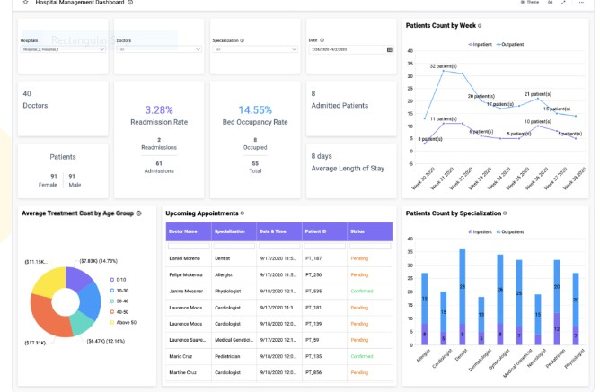

By tracking metrics such as the ratio of doctors to patients, leaders can ensure that hospitals are adequately staffed. We can easily see this data through the “Doctors” and “Admitted Patients” cards. Also, with KPIs such as occupancy rate, readmission rate, and average length of stay, hospital administrators can track trends that may occur over time. This information could help leaders analyze the efficacy of their practices. For example, if readmission rates rise, they might consider updating their discharge procedures; perhaps staff could spend more time explaining medication and other follow-up care details to patients.

Finally, the line graph charting weekly patient intake provides a quick visual reference for any spikes or drop offs that may occur

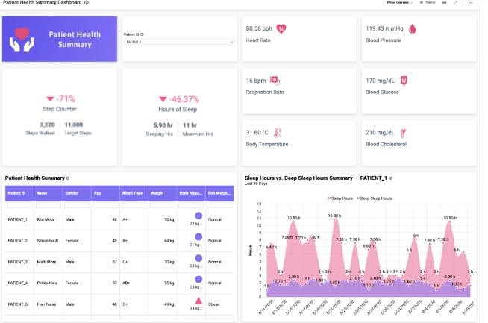

The above healthcare dashboard displays key pieces of data relating to patient’s overall health. By using this dashboard, healthcare providers can view the patient’s vital signs, daily steps, and hours slept, along with a detailed analysis of how many hours of deep sleep they experienced each night. Having this information available in one convenient location makes it easy for healthcare providers to view updated readings of patients vital signs while also tracking key pieces of data (such as sleep quality) over longer periods of time.

**DISADVANTAGES OF EXISTING SYSTEM:**

* Better design would improve the efficiency of health care management.
* Little accommodation of patients diverse demands and needs
* Public perception of the health care system is impacted by negative experiences and the politicized debates over reform and best practices.

**REFERENCES:**

1)Mohammad Ahmad Alkhatib School of Systems, Management and Leadership University of Technology Sydney Sydney, Australia

2)Amir Talaei-Khoei School of Systems, Management and

Leadership University of Technology Sydney Sydney, Australia

3)Amir Hossein Ghapanchi School of Information and Communication Technology Griffith University Queensland, Australia.

4)Abbott, PA & Coenen, A 2008, 'Globalization and advances in information and communication technologies: The impact on nursing and health', Nursing Outlook, vol. 56, no. 5, pp 238- 246.

5) Al-Azzawi, H. 2014. “Caradigm healthcare analytics.” http://www.caradigm.com/media/68911/Caradigm-WP-HealthcareAnalytics-Jan-2014-US-EN.PDF Retrieved 09 August, 2015.